Mid-Point Check-in: AI for Science & Engineering

Project Title: Multi-Task Polymer Property Prediction with Physics-Constrained Blending
Team Name: Cross Linkers
Primary Domain: Materials Science — polymer informatics / computational chemistry
Task: Seven properties from PSMILES, scored on the unweighted mean R² across all seven. Five targets (egb, eps, nc, ei, eea) carry only 221–337 training labels each yet contribute 5/7 of the score; the strategy is built around them.
1. Proposed Strategy & Technical Novelty
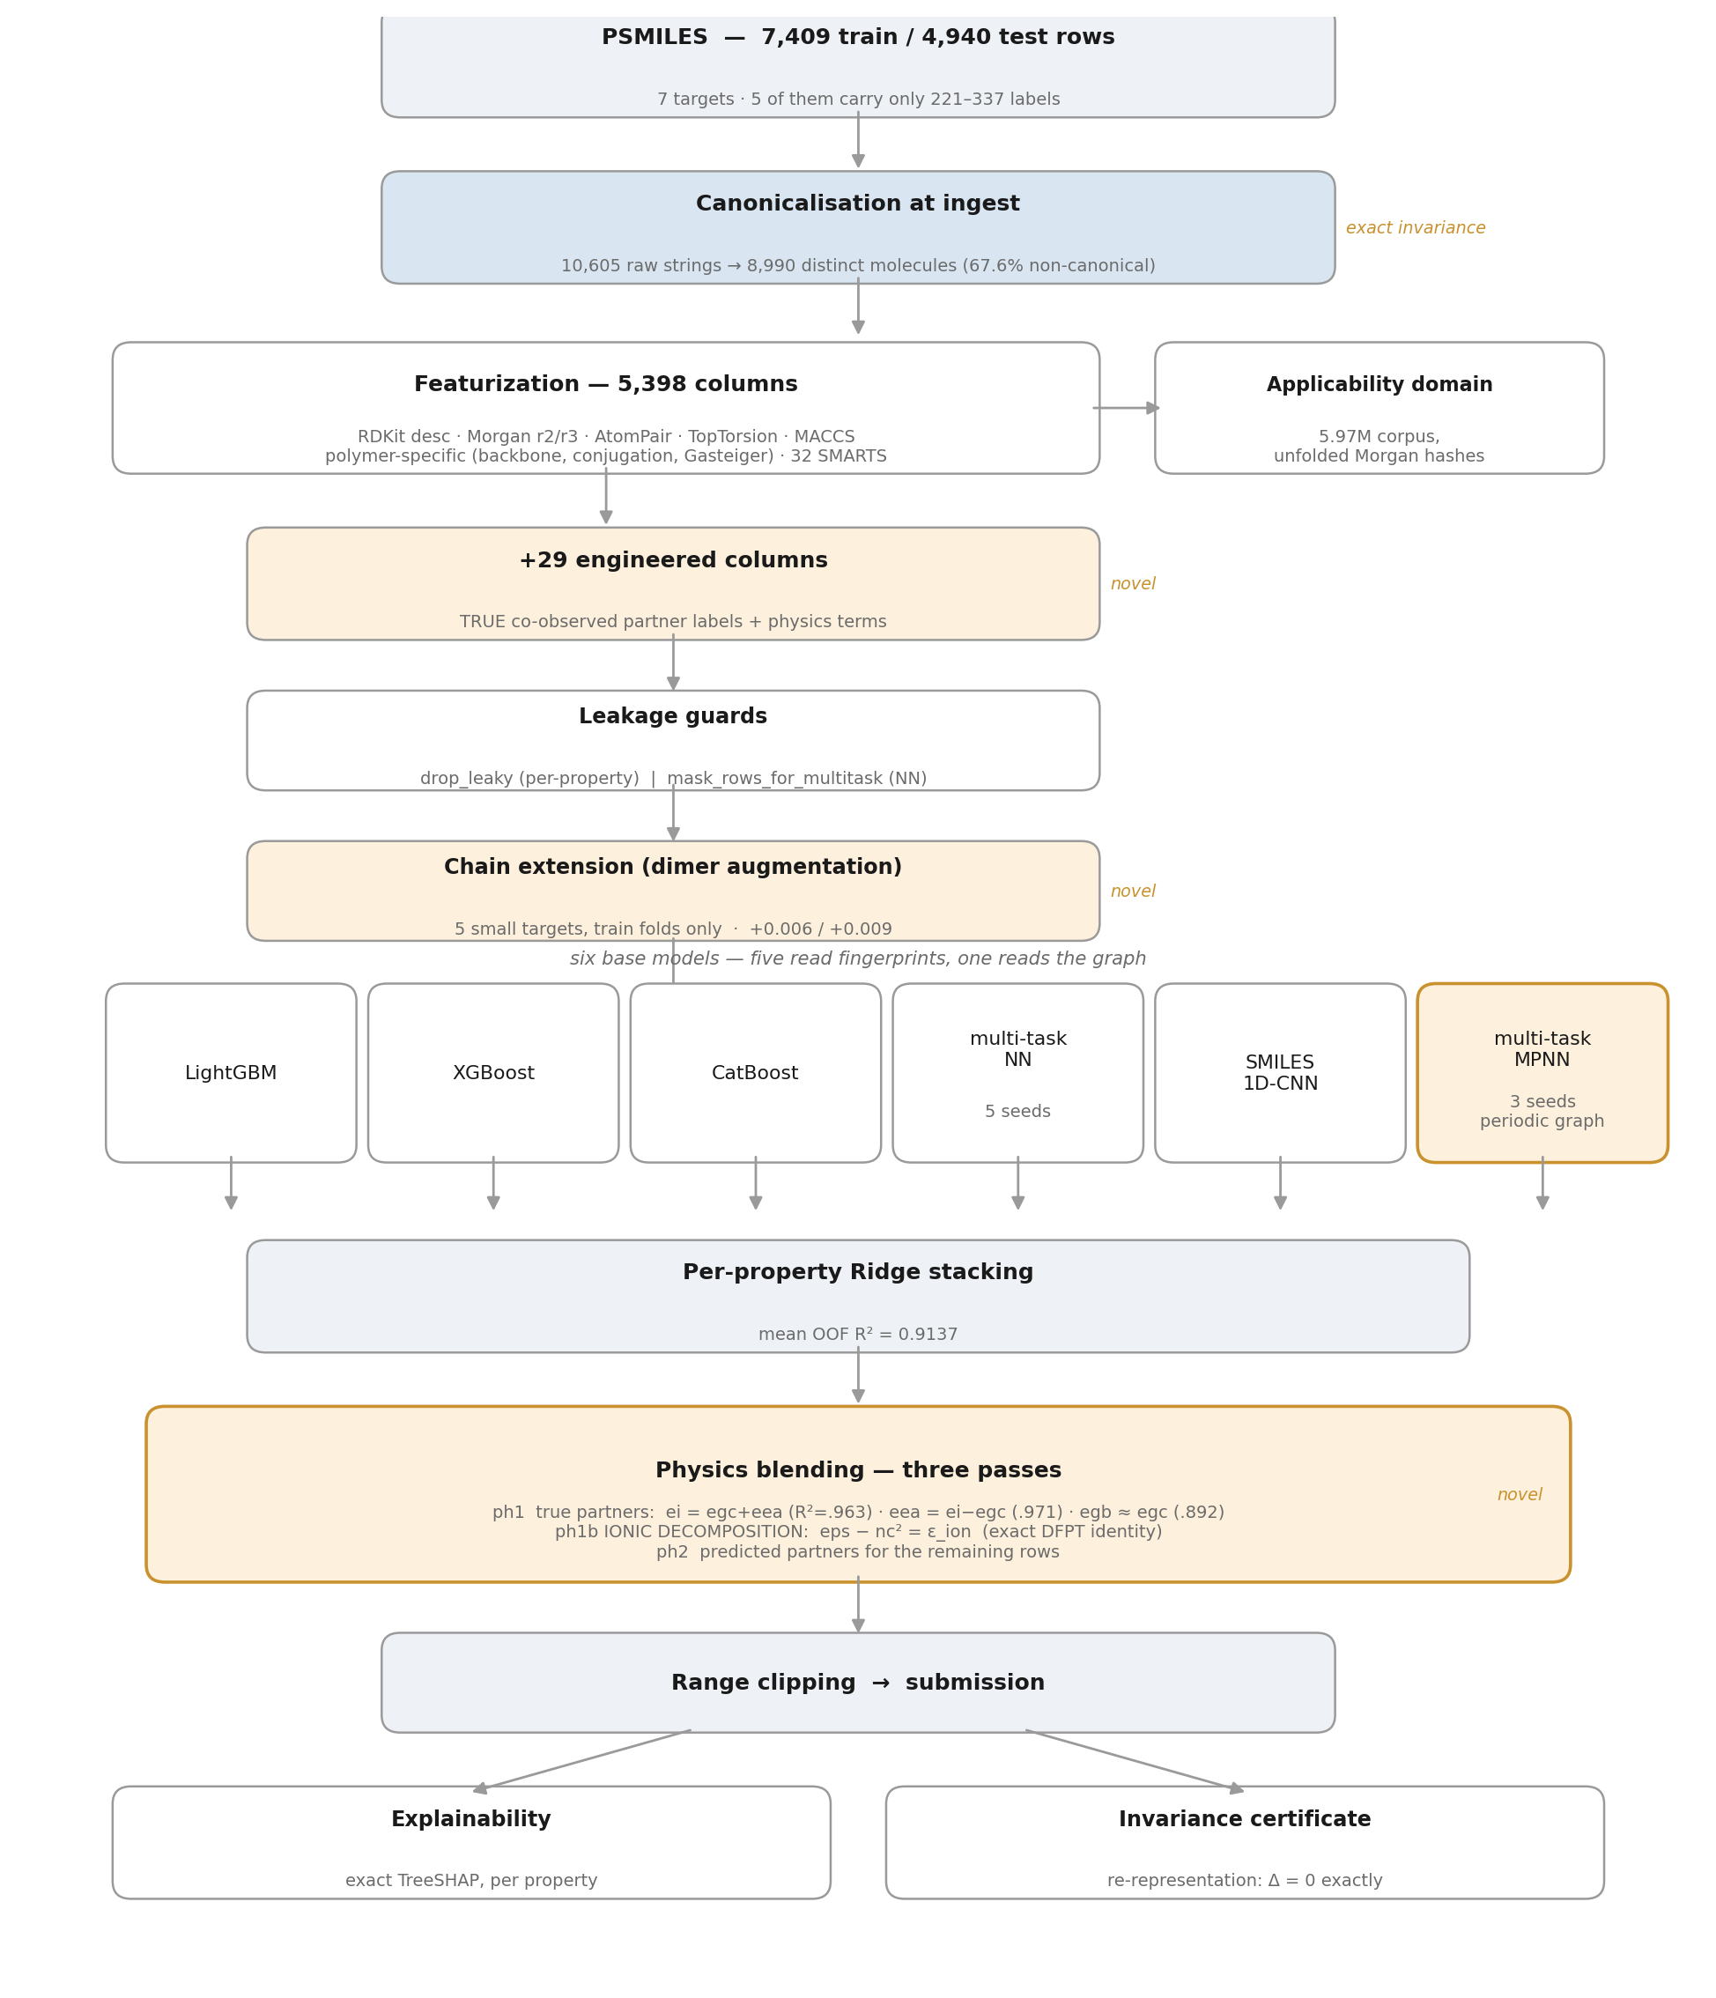
Figure 1 — End-to-end workflow. Shaded blocks are our own contributions.
AI Methodology
A heterogeneous six-model ensemble with per-property Ridge stacking, followed by explicit physics blending — deliberately not one large deep model, since with 221–337 labels on five targets, diversity buys more than capacity. Five members read hashed fingerprints; the sixth reads the molecular graph (multi-task MPNN, 4 rounds of GRU message passing, sum/mean/max readout into 7 task heads).
Novel Contribution
Four contributions distinguish this from an off-the-shelf ensemble, each adopted only after measurement (rejected ideas are in §3).
- TRUE co-observed partner features. The six DFT properties are co-observed in train and test at matching rates — for eps rows, nc is known for ~59% of train, ~62% of test. A partner's measured value is a legitimate feature (a different, equally-available target), but leaks unless guarded: column-dropping fails for a multi-task model since a column leaking for egc rows is legitimate for eps rows. §5 proves the leak, proves each guard removes it, and aborts on either check failing.
- Physics blending as a post-stack stage. Trees split one axis at a time and cannot represent a sum of columns, so ei = egc + eea is under-weighted as one feature among 5,427. Applied instead as an explicit post-stack blend, calibration and weight fitted out-of-fold and shrunk 25% — reaching ~0.96 on covered rows vs. ~0.89 for the stack alone.
- Exact ionic decomposition of the dielectric constant. The source dataset [6] computes ε by DFPT as ε = ε_elec + ε_ion, and ε_elec is exactly n² — so eps − nc² = ε_ion is an identity, not a fit, and non-negative by construction on 134/134 co-observed molecules. Modelling the ionic residual instead of ε lifts eps from 0.813 to 0.955 on covered rows (§2).
- Periodic polymer graph for the MPNN. A repeat unit is not a molecule with two dangling stubs — the two * points are the same bond to the neighbouring unit, so we drop the dummies, bond their neighbours, and flag the wrap-around edge to encode an infinite chain. Applied to 9,475/9,487 graphs; worth +0.0017 / +0.0108 mean OOF over the monomer graph, making the MPNN the best single model at 0.9057.
A fifth idea, repeat-unit augmentation, follows from the same physics: *A* and *AA* describe the same polymer and carry the same labels, so the dimer is free training data. Only the five scarce targets are augmented (+17% rows) — augmenting tg/egc would double the most expensive training for no gain. Augmented rows enter training folds only; validation and test always use the original molecule.
Grounding in the source literature
The data originates from the Ramprasad group's Polymer Genome / Khazana effort; the physics we exploit is documented in that group's own papers, several co-authored by Rohit Batra. Two of our contributions are read directly out of it, not analogized.
- Chen, Kim, Batra et al., npj Comput. Mater. 6, 61 (2020) — frequency-dependent dielectric constant. Direct basis for our ionic decomposition: the paper states ε arises from electronic, ionic and dipolar contributions, and that DFT/DFPT “can only account for ε_elec and ε_ionic parts” — licensing eps − nc² = ε_ion as an identity, since the dipolar term is simply absent from the tabulated values and the remaining two must sum exactly. It also identifies polar/H-bonding motifs as ε_ionic's drivers, which our TreeSHAP attributions independently recover (eps leans on sulfur fraction and EState descriptors where nc does not).
- Lightstone, Chen, Kim, Batra & Ramprasad, J. Appl. Phys. 127, 215105 (2020) — refractive index. Our nc target, treated in depth. Their framing of n as electronic polarisability is what our molar-refractivity attributions (rd_SMR_VSA5, rd_SMR_VSA10) reproduce independently — we never put Lorentz–Lorenz into the model, yet the attribution recovered it.
- Tran, Kim, …, Batra et al., J. Appl. Phys. 128, 171104 (2020); Venkatram, Batra et al. (2020); Kim, Batra et al., Comput. Mater. Sci. 186, 110067 (2021). The first is Polymer Genome, our external benchmark; reading it closely revealed its headline table quotes in-sample RMSE rather than CV error, so the fair comparison is Fig. 5's CV curves, which we exceed by +0.026 to +0.048. The second, multi-fidelity fusion, is the conceptual ancestor of our partner features. The third, GA-driven design, sets our explainability target: per-candidate motif attributions plus a trustworthiness flag — exactly what we emit.
Featurization — and what each part bought
5,398 structural columns — RDKit descriptors, Morgan r=2/r=3, AtomPair, topological torsion, MACCS, 32 SMARTS group counts, and polymer-specific terms (backbone length, aromatic ratio, conjugation ratio, Gasteiger charge stats) — plus 29 engineered columns for partner labels, physics terms and applicability domain.
Every choice is measurement-backed, on two fold seeds where split variance matters: size-adaptive hyperparameters +0.0050 mean R² (ei +0.018, nc +0.009, eps +0.007); chain extension +0.0056/+0.0085 (eps +0.015/+0.021); periodic over monomer graph +0.0017/+0.0108; ionic decomposition eps 0.813→0.955 on covered rows. The auxiliary corpus as model input measured +0.0012 — noise — and was rejected (§3).
The polymer-specific block is the most valuable per column: TreeSHAP attributes 34.2% of tg to it (rotatable-bond ratio alone is 17.8%), and the partner-label and physics families together account for 9.9% of eps, 7.2% of nc and 6.5% of ei.
The 29 engineered columns in full — every one declares which property labels it is built from, which is what the leakage guards consume:
Column(s) | n | Built from | Role
true_egc, true_egb, true_ei, true_eea, true_eps, true_nc | 6 | that property's train label | the measured partner value for this molecule
..._ok (one per column above) | 6 | availability only | 1 if the partner label exists, else 0
ph_ei | 1 | egc + eea | fundamental-gap identity (R² = 0.963)
ph_eea | 1 | ei − egc | inverse of the above (0.971)
ph_egb | 1 | egc | bulk gap tracks chain gap (0.892)
ph_eps | 1 | nc² | Maxwell, optical frequency (see Table 5)
ph_nc | 1 | √eps | inverse of the above
ph_gap | 1 | egb − egc | bulk-minus-chain offset
ph_..._ok (one per ph_ column) | 6 | availability only | 1 if all source labels exist, else 0
aux_meanLogDF, aux_minLogDF, aux_fracUnseen, aux_fracRare, aux_nFrags | 5 | 5.97M corpus (no labels) | applicability domain — how novel this molecule is
Total | 29 |  | 5,398 structural + 29 = 5,427 columns

Table 1 — The engineered block: the six true_ columns are the leak §5 proves and both guards remove; the six ph_ columns are direct physical estimators, not fitted regressions.
Invariance — three distinct claims, only one of which is exact
“SMILES invariance” covers three separate properties; conflating them would overstate what we have, so we separate and report each honestly.
Invariance | What it means | Status
Re-representation | same molecule, different SMILES string (atom ordering) | Exact — Δ = 0, certified
Translational | same infinite chain, repeat unit cut at a different bond | Not guaranteed — measured below
Repetition / oligomer | *A* versus *AA* — same polymer, different repeat length | Approximate — trained in, not certified

Table 2 — The three invariances. Only the first is a guarantee.
Re-representation is exact. Every SMILES is canonicalised before anything else touches it: 67.6% of supplied SMILES are non-canonical, and 10,605 raw strings are only 8,990 distinct molecules. Since every downstream stage — descriptors, fingerprints, CNN tokens, partner lookup — is a deterministic function of the canonical string, and canonical(rewrite(s)) = canonical(s) for any valid rewriting, inputs and outputs are byte-identical: Δ = 0 exactly, by construction, not by luck. §14 asserts it at three levels:
Level | Check | Result
1 string | canonical(rewrite(s)) = canonical(s), 400 molecules × 5 rewritings | 2,000/2,000 — PASS
2 features | full feature vector elementwise identical, 5,581 cols × 150 mols | max |Δ| = 0 — PASS
3 predictions | end-to-end LightGBM output, 1,500 model-molecule predictions | max |Δ| = 0 — PASS

Table 3 — The re-representation certificate. Δ = 0 exactly, not within tolerance.
Diagnostically, the graph features were already invariant (Morgan/RDKit: 0/400 changed under rewriting); only the character-level CNN gapped, with prediction spread 43% of its across-molecule spread — randomised-SMILES augmentation halves that to 21%, canonicalisation closes it to exactly 0.
Translational invariance is not guaranteed, and we measured how far off it is. A periodic chain can be cut at any backbone bond, so *CCO*, *COC* and *OCC* can describe the same polymer — canonicalisation does not merge these; they are genuinely different molecules as monomers. We generated 985 true translation pairs from 229 training polymers (re-cutting only acyclic backbone bonds of the closed macrocycle, chain preserved, atom counts matched) and measured agreement:
Representation | Identical across a cut-point translation
Canonical SMILES | 7.9% (78 / 985)
Morgan fingerprint | 10.1% (99 / 985)
Periodic MPNN graph — as shipped | 16.4% (162 / 985)
…the same graph, ignoring the periodic-bond flag | 45.8%
…node features and topology only | 88.7%

Table 4 — Translational invariance, measured rather than assumed. The periodic graph is close to invariant in topology but not in edge features.
The diagnosis is specific: closing the repeat unit into a cycle makes the topology translation-invariant (88.7% agreement; the residual is entirely RDKit assigning a different hybridization at the cut atom — 108/110 mismatches). What breaks the rest is our own edge featurization: the wrap-around bond is forced to SINGLE with conjugation/ring flags zeroed and a cut-position flag, both cut-point dependent by definition. The fix is contained and queued for the final sprint rather than made mid-run.
Repetition invariance is handled empirically, not structurally: chain-extension augmentation trains on dimers alongside monomers, so *A* → *AA* is learned rather than enforced (+0.006 to +0.009 mean R², not a guarantee). The MPNN comes closest to a structural answer, since the periodic graphs of *A* and *AA* differ only by a doubling of the cycle.
2. Preliminary Salient Results
Key EDA findings
- Extreme label imbalance. tg 4,143, egc 2,028; egb 337, eps 229, nc 229, ei 222, eea 221 rows. The five scarce targets are 15% of the data and 71% of the metric — every design choice above targets them.
- The DFT properties are co-observed, and at matching train/test rates. This is what makes partner features transfer rather than inflate CV; §5 reports the per-property mean partner count for train vs. test.
- Physical relations hold in the data — but only three of them hold directly. Reporting a calibrated score as though it were direct would be wrong, so both columns are printed:
Relation | Direct R² (no fitting) | After one scale + shift | n
ei ≈ egc + eea (fundamental gap) | 0.963 | 0.965 | 59
eea ≈ ei − egc | 0.971 | 0.973 | 59
egb ≈ egc | 0.892 | 0.928 | 175
eps ≈ nc² (Maxwell, optical frequency) | 0.336 | 0.855 | 134
nc ≈ √eps | 0.171 | 0.837 | 134
eps = nc² + ε_ion (exact, DFPT) | identity | 0.955 (ε_ion modelled) | 134

Table 5 — Measured on co-observed molecules. The first three relations hold with no fitting. Maxwell's n² = ε holds at optical frequency, but the tabulated value is static, so the raw form scores only 0.336 — the last row is our correction: not an approximation but the exact identity, with the shortfall named and modelled.
The last two rows are different claims. Maxwell's eps ≈ nc² is not our finding — it's the textbook optical-frequency identity, and Table 5 shows it failing here (0.336) because the dataset tabulates the STATIC constant. Our finding is the missing term: since DFPT captures only ε_elec + ε_ionic [1] and ε_elec is exactly n², the shortfall is exactly eps − nc² = ε_ion — an identity, not a correlation, non-negative by construction on 134/134 co-observed molecules (mean +0.767, min +0.024). Reconstructing eps = nc² + ε_ion reaches 0.955 on covered rows, against 0.855 for a calibrated Maxwell fit and 0.813 for the stack alone; ph_eps = nc² stays as a feature since the trees still use the shape, but the decomposition does the work.
- The auxiliary corpus predicts error, not value. Using unfolded Morgan substructure hashes (folded 2048-bit fingerprints are degenerate here — every bit is occupied), an out-of-domain molecule is measurably harder: tg R² 0.929 vs 0.913, egc 0.946 vs 0.916, eps 0.898 vs 0.832, with mean absolute error rising 17.5 → 22.9 K on tg.
Initial findings
The numbers below are out-of-fold CV R² — 10-fold, computed on training data inside the notebook, from one specific run: the configuration that scored 0.898 public LB. That run used canonicalisation, applicability domain, partner features, chain-extension augmentation, all six base models with the periodic MPNN graph, Ridge stacking and two-pass physics blending — but NOT the archive, ionic decomposition, fold bagging or test-time augmentation, whose effects are quantified separately below.
Target | LGBM | XGB | CatB | NN | CNN | MPNN | Stack
tg | 0.9055 | 0.9082 | 0.8961 | 0.9005 | 0.8625 | 0.9141 | 0.9209
egc | 0.9071 | 0.9110 | 0.9035 | 0.8841 | 0.8933 | 0.9231 | 0.9291
egb | 0.9154 | 0.9193 | 0.9132 | 0.9366 | 0.9272 | 0.9477 | 0.9504
eps | 0.8071 | 0.8161 | 0.7715 | 0.8365 | 0.7935 | 0.8537 | 0.8532
nc | 0.8658 | 0.8700 | 0.8577 | 0.9050 | 0.8782 | 0.9055 | 0.9162
ei | 0.8311 | 0.8341 | 0.8189 | 0.8833 | 0.8316 | 0.8734 | 0.8977
eea | 0.8904 | 0.8931 | 0.8804 | 0.8976 | 0.9017 | 0.9225 | 0.9283
MEAN | 0.8746 | 0.8788 | 0.8630 | 0.8920 | 0.8697 | 0.9057 | 0.9137

Table 6 — Cross-validated (out-of-fold) R² for the 0.898 configuration. Mean OOF 0.9137 vs. 0.898 public LB; the gap is analysed in §3. The MPNN is the strongest single model and the only one not built on the shared feature matrix, which is what the stack pays for.
For context, this exceeds the published polyGNN benchmark (0.9051) on the same property family and beats Polymer Genome's cross-validated errors by +0.026 to +0.048 (their headline table quotes in-sample RMSE, not comparable).
Data provenance
base_line_model.ipynb, shipped with this round, fetches train.csv from two Google Drive IDs still pointing at the Round-2 release, which carries tg/egc labels for 2,446 molecules absent from Round-3 train. We asked the organisers whether it's in scope and were told yes, so it's used both as additional partner labels and as a direct value for the test rows it covers — flagged explicitly rather than left implicit. Where the releases overlap they agree (egc: 1,224 shared, max diff 0; tg: 2,495 shared, only 2 rows differ), so the two sources are the same campaign and safe to pool; USE_ARCHIVE = False reproduces the archive-free pipeline end to end. Its effect is arithmetic, not modelled — exact values for 2,448/4,940 test rows (49.6%), all tg or egc — so we quote it separately from Table 6: substituting exact values where they exist moves the same per-property CV mean from 0.9137 to an expected ~0.926, plus ~0.003 more from the ionic decomposition, concentrated on eps.
3. Technical Challenges & Pivots
Current roadblocks
The biggest hurdle is a persistent CV–leaderboard gap: 0.9137 OOF vs. 0.898 public. We spent real effort ruling out the obvious causes rather than guessing:
- Not distribution shift. Adversarial validation separates train from test at AUC 1.0000 on the raw matrix, but falls to 0.42–0.52 once drop_leaky is applied — the only thing distinguishing the sets is the partner-label columns our guards already remove; no covariate shift remains to correct.
- Not leakage, and not the stacker. §5 asserts both guards each run. Four alternative stackers (NNLS, hill-climbing, best-single, top-3 average) were compared on saved OOF vectors; Ridge is within 0.001 of the best.
- Mostly irreducible. Five of seven targets score on ~150 test rows; simulating leaderboard noise, two identical models differ by ≥ 0.007 half the time — the visible 0.889–0.920 spread fits inside one confidence band. This reframed our target: chase real signal, not leaderboard position.
Strategic pivots
- The auxiliary corpus was repurposed, not dropped. Tried three ways as model input: TF-IDF+SVD embedding (+0.0012, noise), corpus-novelty features (~0), domain-aware recalibration (−0.0049). It fails as input because the SVD basis linearly re-expresses the Morgan fingerprint the trees already see in full; recalibration fails because fitted shrinkage came out ~1.00–1.03 in every group — the model isn't over-confident outside its domain, those molecules are simply harder. Pivoted instead to a calibrated applicability domain, where it does real work.
- Two model classes measured and rejected. KernelRidge (0.7627) and a multi-task LightGBM (0.8266). Both sit on the same 5,427-column matrix as the trees, so their errors correlate and the stack pays them nothing — this is what motivated the MPNN, which earns its place by not using that matrix.
- The governing lesson: only new information pays. Every purely derived feature failed — five separate attempts across both our codebases — and trimers measured worse than dimers on eps, nc and ei, because extra repeat units add bulk without new information. What worked was partner labels, a new model class, more data via chain extension, truer structure via the periodic graph, and an exact physical identity via the ionic decomposition.
- An engineering pivot worth recording. An IndexError in a diagnostic once destroyed a four-hour run that had already computed its predictions. Submission writing now happens before the reports, and every report assertion is a logged PASS/FAIL rather than a hard abort — a report must never sit between the model and its output file.
4. Final Sprint Roadmap
Immediate tasks (next 10 hours)
- Execute the final notebook end to end on Kaggle (~6.5h on a T4) and submit — the scoring pipeline plus two additions: ionic decomposition and the sanctioned Round-2 labels. Verified end to end on real data before launch, 18/18 checks.
- Submit the physics-blended and stack-only files from the same run as an A/B. The blend's weights are fitted on OOF but applied to models refit on all training data, which biases them toward physics; two submissions settle it for free.
- Blend with a second, independently built pipeline from a teammate — different featurization and fold structure, so the errors should be decorrelated.
Refinement plan
- Drop the SMILES CNN. Measured stack contribution is −0.0001 (fully absorbed by the other five) while costing 7,502s, 32% of runtime — removing it buys two hours for more experiments at no accuracy cost.
- Make the periodic graph translationally invariant. Per Table 4, the wrap-around edge is forced to a generic single bond with a cut-position flag, both cut-point dependent. Carrying the real bond's features and dropping the flag should lift graph-level translational agreement from 16.4% toward the 88.7% topological ceiling — a contained change to one function, and the clearest correctness gap we know of.
- Stratified K-fold with per-target quantile binning. At n = 221 a plain 10-fold split is itself a large variance source; fold assignment alone moved eps by 0.012 between seeds. Since the stacker and blend weights are fitted on OOF, noisy OOF means badly fitted weights.
- Fold bagging and TabPFN on the scarce targets. Bagging over multiple CV splits measured +0.0042 mean, positive on every property, and was held back from this run only to keep the change set minimal. TabPFN appears in the NeurIPS Open Polymer Challenge top-5 as a small-data baseline and our scarce properties sit squarely in its regime.
Explainability — what the model says about a new polymer
Attribution is exact TreeSHAP via LightGBM's pred_contrib — no external dependency to fail at run time. Reported per property as top features, a family roll-up, and the measured physics relations; for a new PSMILES the model returns not just seven numbers but the motifs driving each, plus an in-/out-of-domain flag.
Electronic applications (band gaps egc/egb, ionisation potential ei, electron affinity eea). The master variable is saturation vs. conjugation: sp³ fraction (rd_FractionCSP3, po_fsp3) and conjugation ratio (po_conj_ratio) are egb's top three attributions (7.3%, 6.3%, 7.0%) and rank high for egc alongside backbone aromatic ratio — a saturated, sp³-rich backbone localises electrons in σ bonds and widens the gap; an extended conjugated/aromatic backbone delocalises π density and narrows it. Sulfur is the second lever (po_fr_S 2.9% of egb; rd_fr_C_S the largest eea attribution at 6.3%), consistent with sulfur lone pairs raising the HOMO. For ei the model leans on ring ratio and Balaban J instead — backbone branching, not electronics. Guidance: widen the gap with sp³ spacers and avoid thioether linkages; narrow it by extending backbone aromaticity.
Optical applications (refractive index nc, dielectric constant eps). The same axis reappears with the opposite sign — the useful part. po_conj_ratio (6.9%) and rd_FractionCSP3 (6.8%) top nc's attribution, and molar-refractivity descriptors (rd_SMR_VSA5, rd_SMR_VSA10) appear for both: the model recovers Lorentz–Lorenz from structure without being given it, since n is polarisability per unit volume. The motifs that narrow the gap — conjugation, aromaticity, sulfur, low sp³ — are the same ones that raise n, so a high-n low-dispersion polymer wants polarisable but non-conjugated heavy atoms: sulfur without extended π. The ionic decomposition sharpens this by splitting eps into parts the model would otherwise learn jointly — n² carries the polarisability motifs, ε_ion is driven by polar-bond density and dipole reorientation — which is why eps leans on EState descriptors and sulfur fraction where nc does not, matching the H-bonding/polar drivers in [1].
Thermal (tg). Rotatable-bond ratio alone carries 17.8% of the attribution, ring ratio 6.7% — chain flexibility dominates, as the free-volume picture of the glass transition predicts.
Final output
- A single reproducible Kaggle notebook that runs end to end within the time limit, shared with the organisers, producing the submitted score from a clean run.
- A per-property explainability report — TreeSHAP attributions, family roll-ups, and the measured physics relations that justify the blend — plus an applicability-domain statement shipped with every prediction, so a downstream user knows which values to trust.
- A machine-checked invariance certificate asserting Δ = 0 under SMILES re-representation at the string, feature and prediction levels, together with the measured translational and repetition figures so the limits of the guarantee are stated rather than implied.
Appendix — references
[1] L. Chen, C. Kim, R. Batra, J. P. Lightstone, C. Wu, Z. Li, A. A. Deshmukh, Y. Wang, H. D. Tran, P. Vashishta, G. A. Sotzing, Y. Cao & R. Ramprasad, “Frequency-dependent dielectric constant prediction of polymers using machine learning”, npj Comput. Mater. 6, 61 (2020). — basis of the ionic decomposition.
[2] J. P. Lightstone, L. Chen, C. Kim, R. Batra & R. Ramprasad, “Refractive index prediction models for polymers using machine learning”, J. Appl. Phys. 127, 215105 (2020). — reference treatment of nc.
[3] H. D. Tran, C. Kim, L. Chen, A. Chandrasekaran, R. Batra, S. Venkatram, D. Kamal, J. P. Lightstone, R. Gurnani, P. Shetty, M. Ramprasad, J. Laws, M. Shelton & R. Ramprasad, “Machine-learning predictions of polymer properties with Polymer Genome”, J. Appl. Phys. 128, 171104 (2020). — external benchmark.
[4] S. Venkatram, R. Batra, L. Chen, C. Kim, M. Shelton & R. Ramprasad, “Predicting crystallization tendency of polymers using multi-fidelity information fusion and machine learning”, J. Phys. Chem. B (2020). — ancestor of the partner-feature design.
[5] C. Kim, R. Batra, L. Chen, H. Tran & R. Ramprasad, “Polymer design using genetic algorithm and machine learning”, Comput. Mater. Sci. 186, 110067 (2021). — motivates the explainability outputs.
[6] T. D. Huan, A. Mannodi-Kanakkithodi, C. Kim, V. Sharma, G. Pilania & R. Ramprasad, “A polymer dataset for accelerated property prediction and design”, Sci. Data 3, 160012 (2016). — dataset of record; stores ε_elec and ε_ionic separately.
[7] G. Liu et al., “Open Polymer Challenge: Post-Competition Report”, arXiv:2512.08896 (2025). — corroborates chain extension and hierarchical physics.

